Gentrification Map

Martín Ferrer Escobar

29 November 2019
- Introduction
  - Background
During the past two decades the importance of cities has grown in a considerable way, being the center of the human activity. In a few years more than half of global population will live in cities for the first time in history, concentrating the principal economic activities, and for those reasons is important to rethink the way we understand the cities and approach new problems generated by these dynamics in an innovative way.
One of the problems that are having the main European and American cities is gentrification, a phenomenon that was first used by Ruth Glass in 1964 but specially in the past 15 years has become a popular concept. We can define gentrification as: “The process by which a place, especially part of a city, changes from being a poor area to a richer one, with the population being replaced by members of a higher social class”.
  - Problem
Gentrification is a complex issue and is difficult to face. The better way to act in front of the problem is to try to prevent it of developing. As we have many examples of cities and neighborhoods that have suffered gentrification, there are some characteristics that can help us to diagnose if certain area has certain symptoms, and act in consequence.
Here is where data plays a vital role solving the problem. Analyzing the actual situation of population, rent prices, typology of the venues, between others can help to prevent the situation to develop.
  - Interest
The city halls and public administrations are the principal interested in this methodology, to create documents that help the decision making in the urban planification and development of the measures to protect the citizenship.

- Data acquisition and cleaning

  - Data Sources
As study case we will use the city of Barcelona, Catalonia. So all the information and data sets will be from that city.
There will be used three different data sets during this study. The first data set is one that will be used to have the list of neighborhoods and districts of Barcelona, the second data set have the information of rental prices of each neighborhood for the 2017 year, and the third data set is the information of the venues for each neighborhood and will be extracted from FourSquare.
  - Data Preparation
There is some processing that the data need to have in order to be useful for the final purpose. The first complete data set that is needed is one that contains the following information: “District Name”, “Neighborhood Name”, “Neighborhood Code”, “Neighborhood Latitude”, “Neighborhood Longitude”.
To obtain that data set we will use the Immigration registry for 2015 (any other data set containing neighborhood and district names and codes could be used). First, the columns that have information that is not useful for the final data set were dropped: “Year”, “Nationality”, “Name” and “District Code”. After changing the columns titles to English from Catalan we obtain the following data set:
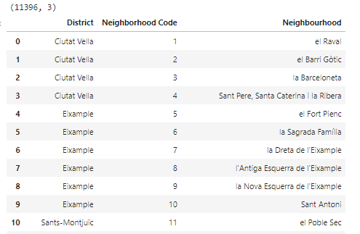
Fig. 1. Data Set of neighborhoods and districts
As you can see the data set has 11396 rows, because at the start the information was the number of immigrants from all nationalities that each neighborhood had, so we had to delete all the rows that name of the name of the neighborhood repeated. After this process the final data set has 74 rows and 3 columns.
Finally, for this data set it was needed to obtain all the coordinates for each row, so the “geopy” library was selected. With a loop every name of the neighborhoods were introduced and a data set containing the X, Y coordinates was obtained. There was a small issue with this function and is that it didn’t recognized the name of three of the neighborhoods, so these were deleted from the data set as we couldn’t work with them.
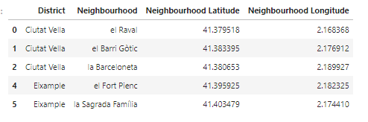
Fig. 2. Data set of the neighborhoods with their respective coordinates
The second data set that we needed to clean was the rental prices data set. The final data set that we need is one that only has two columns, “Neighborhood” and “Price (€/month)”.
As in the first data set, the columns that are not needed are dropped: “Year”,” Trimester”,” District Code”,” District Name”. As this data is grouped by trimesters, there should be four rows for each neighborhood,292, but instead we find that there are 584. Making a quick exploration of the date we find that there is information of the average rent for flat and for m2. As we only want the information for average rent for flat, we should drop the rows containing the information per m2. For this action we use the “Lloguer Mitja” (Average Rent) column, and after dropping the unwanted values, the column is dropped too.
Next, the rent prices are grouped by neighborhoods applying the mean to have the average price for the whole year. And finally, all the prices are transformed from float numbers to integers, that is the format needed for the map visualization later.
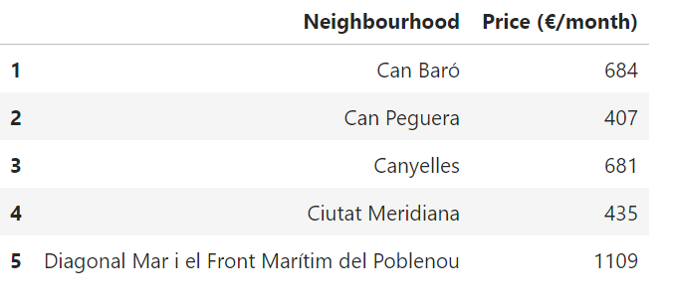
Fig. 3. Rent prices data set

For the third and last data set, FourSquare application is needed. FourSquare have a complete information from most of the venues in cities so it will be useful for determining the most popular type of venue for each neighborhood.
To obtain this data set, two functions must be defined, one that returns the category of each venue, and the other that returns a data frame of venues which contains coordinates, category, neighborhood and neighborhood coordinates.
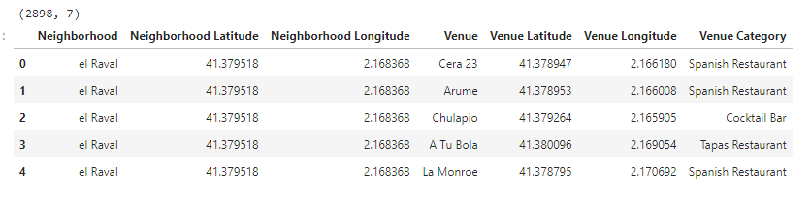
Fig. 4. Venues data set

